DAILY LIFE MANAGEMENT SYSTEM

INTRODUCTION TO DATABASE

**MEMBERS AND CONTRIBUTION**

|  |  |  |  |
| --- | --- | --- | --- |
| NAME | ID | CONTIBUTION | CONTIBUTION |
| SANJIDA AFROJ SWARNA | 20-43681-2 | CREATING WORD DOCUMENT | 20% |
| SUMAIYA MALIK | 20-43688-2 | DATA INSERTION | 20% |
| SOILY GHOSH SNEHA | 20-43702-2 | E-R DIAGRAM | 20% |
| MOHAMMAD SHAFIN | 20-43736-2 | TABLE CREATION | 20% |
| MD. SAZZAD SIDDIQUE | 20-43747-2 | NORMALIZATION | 20% |

**SCENARIO AND DESCRIPTION**

**Scenario:**

This project will record all day-to-day activities done by a user which will help them organizing and managing their day-to-day life. This will help them managing their health and using their time efficiently. A user can track the records of how much calorie they have spent or how much calorie they need for managing a good and sound health and a user can also know how much exercise they need for maintaining their BMI or to change their BMI. It will also track the records of the classes for students which will help them attending the classes with managing their physical health.

**Description:**

This project has 3 entities.

1. User: User will have all the identical attributes.

2. Daily activity: Daily activity will have all the attributes that will be helpful for recording the daily activities.

3. Classes: Classes will have all the classes for those who are student.

All the relation here will be many to many. As many users can have many activities and many classes as well as one activity or one class have many users.

**ER-DIAGRAM:**

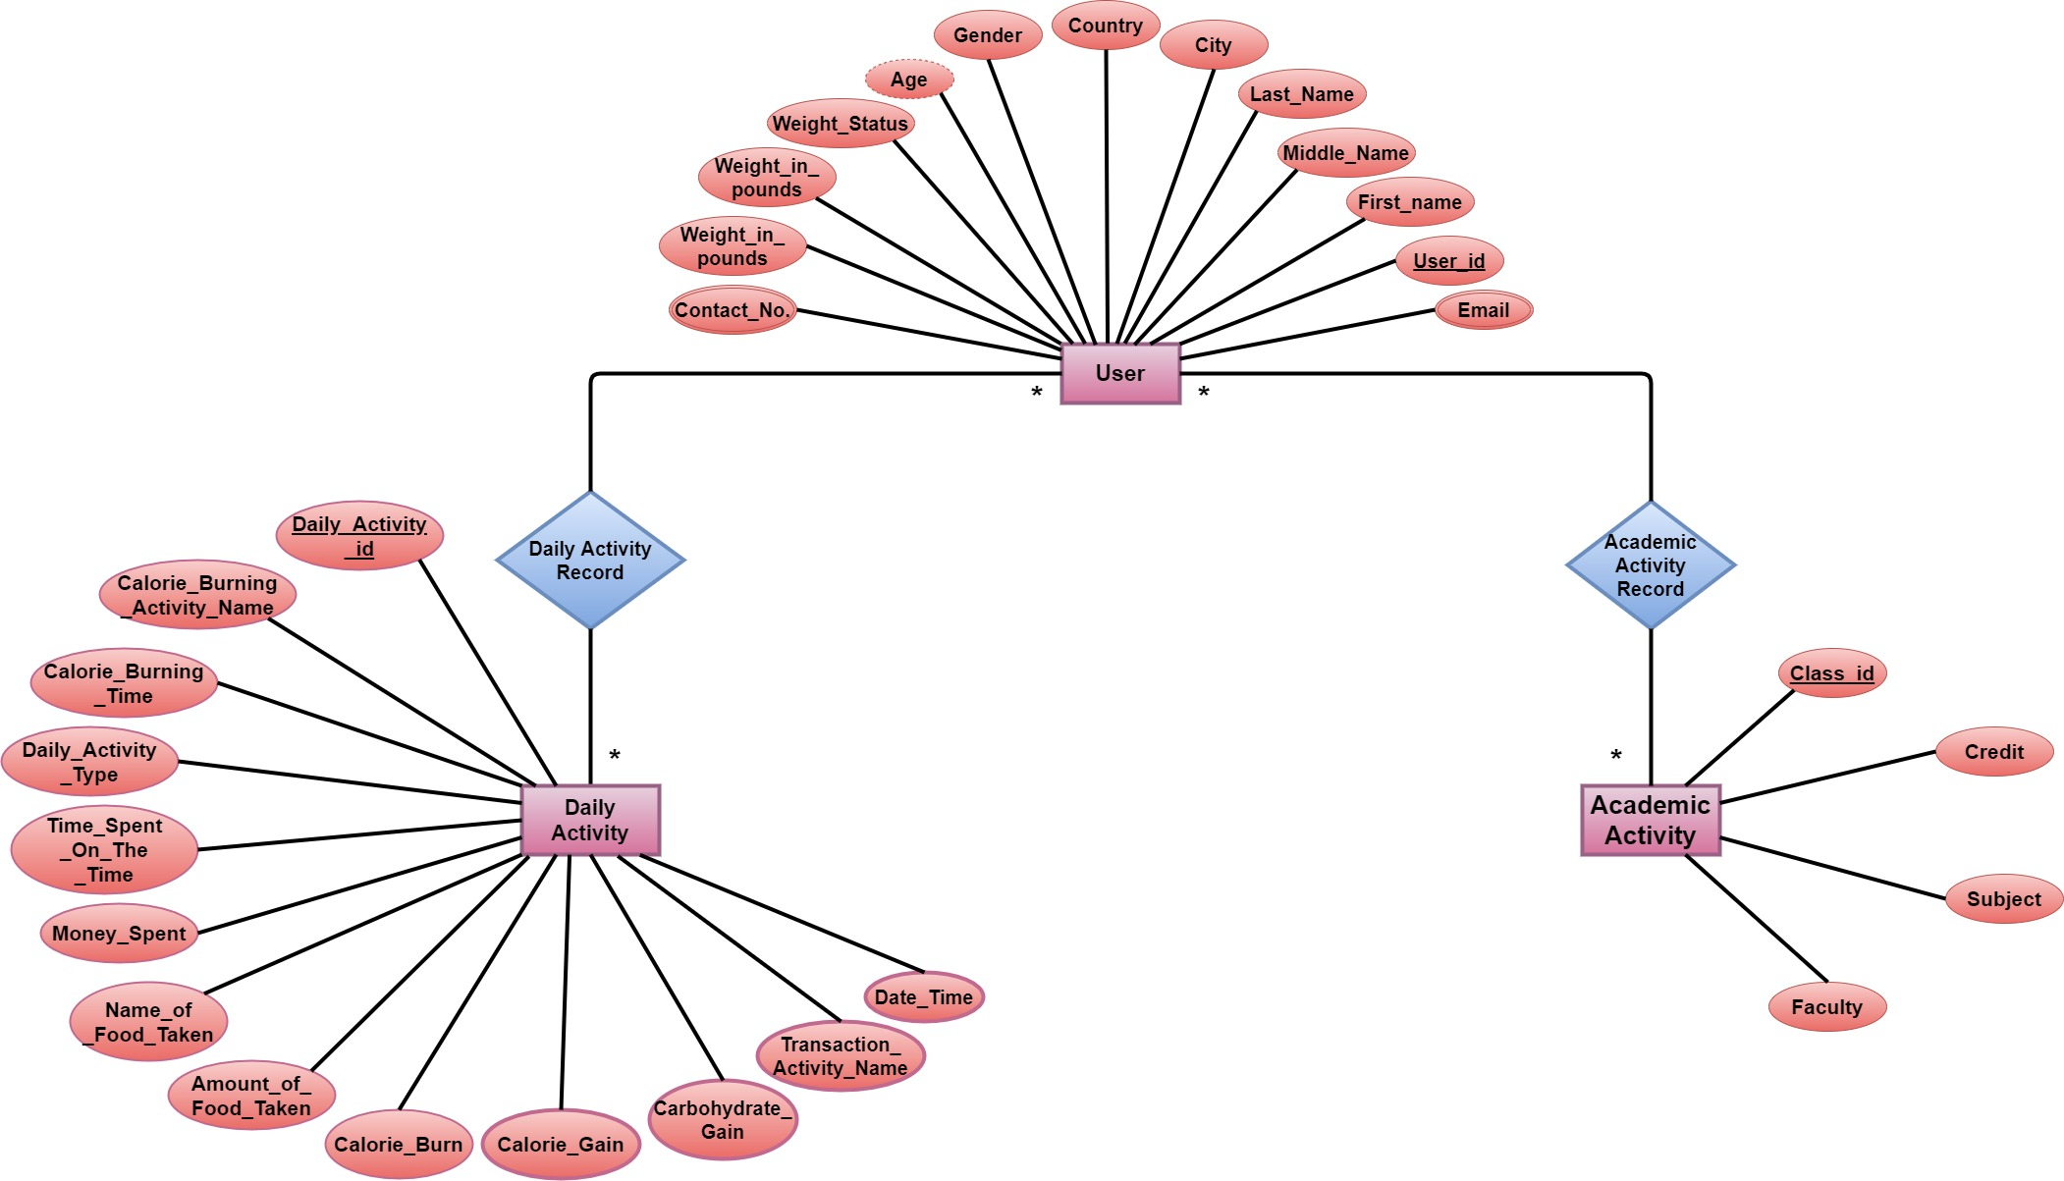

**NORMALIZATION**

**DAILY ACTIVITY RECORDS**

**Daily activity records** - (**user_id**, first_name, middle_name, last_name, gender, age, height_in_inches, weight_in_pounds, weight_status, email, contact_no, city, country, **daily_activity_id**, date_time, daily_activity_type, time_spent_in_minutes, calorie_burning_activity_name, calorie_burning_time,calorie_burnt, name_of_food_taken, amount_of_food_taken, calorie_gain, carbohydrate_gain, transaction_activity_name, money_spent)

**1 NF**:

email, contact_no are multivalued attributes.

**2 NF**:

1. **user_id**, first_name, middle_name, last_name, gender, age, height_in_inches, weight_in_pounds, weight_status, email, contact_no, city, country
2. **daily_activity_id**, date_time, activity_name, activity_type, time_spent_in_minutes, calorie_burning_activity_name, calorie_burnt, name_of_food_taken, amount_of_food_taken, calorie_gain, carbohydrate_gain, transaction_activity_name, money_spent

**3 NF**:

1. user_id, first_name, middle_name, last_name, gender, age, height_in_inches, weight_in_pounds, weight_status, email, contact_no.
2. address_id, user_id, city, country
3. daily_activity_id, date_time, activity_name, activity_type, time_spent_in_minutes
4. daily_activity_id, date_time, name, time_spent_in_minutes
5. **activity_id**, calorie_burning_activity_name, calorie_burnt
6. **food_id**, name_of_food_taken, amount_of_food_taken, calorie_gain, carbohydrate_gain
7. **transaction_id**, transaction_activity_name, money_spent

**TABLES FROM DAILY ACTTIVITY RECORDS:**

1. **user_id**, first_name, middle_name, last_name, gender, age, height_in_inches, weight_in_pounds
2. **weight_status_id**, minimum_bmi, maximum_bmi, weight_status
3. **user_id, email (composite key)**
4. **user_id, contact_no (composite key)**
5. **address_id**, **user_id**, city, country
6. **user_daily_activity_id**, **user_id**, **daily_activity_id**
7. **daily_activity_id**, date_time, name, time_spent_in_minutes
8. **calorie_burning_activity_id**, **daily_activity_id**, activity_id, activity_type
9. **activity_id**, calorie_burning_activity_name, calorie_burnt
10. **calorie_gaining_activity_id**, **daily_activity_id**, food_id, amount
11. **food_id**, name_of_food_taken, amount_of_food_taken, calorie_gain, carbohydrate_gain
12. **transaction_activity_id**, **daily_activity_id**, transaction_id, payment_type
13. **transaction_id**, transaction_activity_name, money_spent

**ACADEMIC ACTIVITY RECORDS**

**Academic activity records** – (user_id, first_name, middle_name, last_name, gender, age, height_in_inches, weight_in_pounds, weight_status, email, contact_no, city, country, class_id, subject, credit, faculty)

**1 NF:**

email, contact_no are multivalued attributes.

**2 NF:**

1. **user_id**, first_name, middle_name, last_name, gender, age, height_in_inches, weight_in_pounds, weight_status, email, contact_no, city, country
2. **class_id**, subject, credit, faculty

3 NF:

1. user_id, first_name, middle_name, last_name, gender, age, height_in_inches, weight_in_pounds, weight_status, email, contact_no.
2. address_id, user_id, city, country
3. class_id, subject, credit, faculty

**TABLES FROM ACADEMIC ACTIVITY RECORDS:**

1. **user_id**, first_name, middle_name, last_name, gender, age, height_in_inches, weight_in_pounds
2. **weight_status_id**, minimum_bmi, maximum_bmi, weight_status
3. **user_id, email (composite key)**
4. **user_id, contact_no (composite key)**
5. **address_id**, **user_id**, city, country
6. **user_class_id**, date_time, **user_id**, **class_id**
7. **class_id**, subject, credit, faculty

**TABLES**

1. **user_id**, first_name, middle_name, last_name, gender, age, height_in_inches, weight_in_pounds -> **USER_RECORDS**
2. **weight_status_id**, minimum_bmi, maximum_bmi, weight_status -> **WEIGHT_STATUS**
3. **user_id, email** -> **USER_EMAIL_RECORDS**
4. **user_id, contact_no** -> **USER_CONTACT_NO_RECORDS**
5. **address_id**, **user_id**, city, country -> **USER_ADDRESS_RECORDS**
6. **user_daily_activity_id**, **user_id**, **daily_activity_id** **USER_DAILY_ACTIVITY_RECORDS**
7. **daily_activity_id**, date_time, name, time_spent_in_minutes -> **DAILY_ACTIVITY_RECORDS**
8. **calorie_burning_activity_id**, **daily_activity_id**, activity_id, activity_type -> **USER_CALORIE_BURNING_RECORDS**
9. **activity_id**, calorie_burning_activity_name, calorie_burnt -> **CAL_BURNT_BY_ACT_RECORDS**
10. **calorie_gaining_activity_id**, **daily_activity_id**, food_id, amount -> **USER_CALORIE_GAINING_RECORDS**
11. **food_id**, name_of_food_taken, amount_of_food_taken, calorie_gain, carbohydrate_gain -> **FOOD_RECORDS**
12. **transaction_activity_id**, **daily_activity_id**, transaction_id, payment_type -> **USER_TRANSACTION_RECORDS**
13. **transaction_id**, transaction_activity_name, money_spent -> **TRANSACTION_RECORDS**
14. **user_class_id**, date_time, **user_id**, **class_id** -> **USER_CLASS_RECORDS**
15. **class_id**, subject, credit, faculty -> **CLASS_RECORDS**

|  |  |  |  |  |
| --- | --- | --- | --- | --- |
| TABLE NUMBER | TABLE NAME | COLUMN NAMES | PRIMARY KEY | FOREIGN KEY |
| 1 | **USER_RECORDS** | **user_id, first_name, middle_name, last_name, gender, age, height_in_inches, weight_in_pounds** | **user_id** | **-** |
| 2 | **WEIGHT_STATUS** | **weight_status_id, minimum_bmi, maximum_bmi, weight_status** | **weight_status_id** | **-** |
| 3 | **USER_EMAIL_RECORDS** | **user_id, email** | **user_id, email** | **-** |
| 4 | **USER_CONTACT_NO_RECORDS** | **user_id, contact_no** | **user_id, contact_no** | **-** |
| 5 | **USER_ADDRESS_RECORDS** | **address_id, user_id, city, country** | **address_id** | **user_id** |
| 6 | **USER_DAILY_ACTIVITY_RECORDS** | **user_daily_activity_id, user_id, daily_activity_id** | **user_daily_activity_id** | **user_id, daily_activity_id** |
| 7 | **DAILY_ACTIVITY_RECORDS** | **daily_activity_id, date_time, name, time_spent_in_minutes** | **daily_activity_id** |  |
| 8 | **USER_CALORIE_BURNING_RECORDS** | **calorie_burning_activity_id, daily_activity_id,**  **activity_id, activity_type** | **calorie_burning_activity_id** | **daily_activity_id,**  **activity_id** |
| 9 | **CAL_BURNT_BY_ACT_RECORDS** | **activity_id, calorie_burning_activity_name, calorie_burnt** | **activity_id** | **-** |
| 10 | **USER_CALORIE_GAINING_RECORDS** | **calorie_gaining_activity_id, daily_activity_id, food_id, amount** | **calorie_gaining_activity_id** | **daily_activity_id, food_id** |
| 11 | **FOOD_RECORDS** | **food_id, name_of_food_taken, amount_of_food_taken, calorie_gain, carbohydrate_gain** | **food_id** | **-** |
| 12 | **USER_TRANSACTION_RECORDS** | **transaction_activity_id, daily_activity_id, transaction_id, payment_type** | **transaction_activity_id** | **daily_activity_id, transaction_id** |
| 13 | **TRANSACTION_RECORDS** | **transaction_id, transaction_activity_name, money_spent** | **transaction_id** | **-** |
| 14 | **USER_CLASS_RECORDS** | **user_class_id, date_time, user_id, class_id** | **user_class_id** | **user_id, class_id** |
| 15 | **CAL_BURNT_BY_ACT_RECORDS** | **class_id, subject, credit, faculty** | **class_id** | **-** |

**TABLE DESCRIPTION**

1. **USER_RECORDS:**

1. **WEIGHT_STATUS:**

1. **USER_EMAIL_RECORDS:**

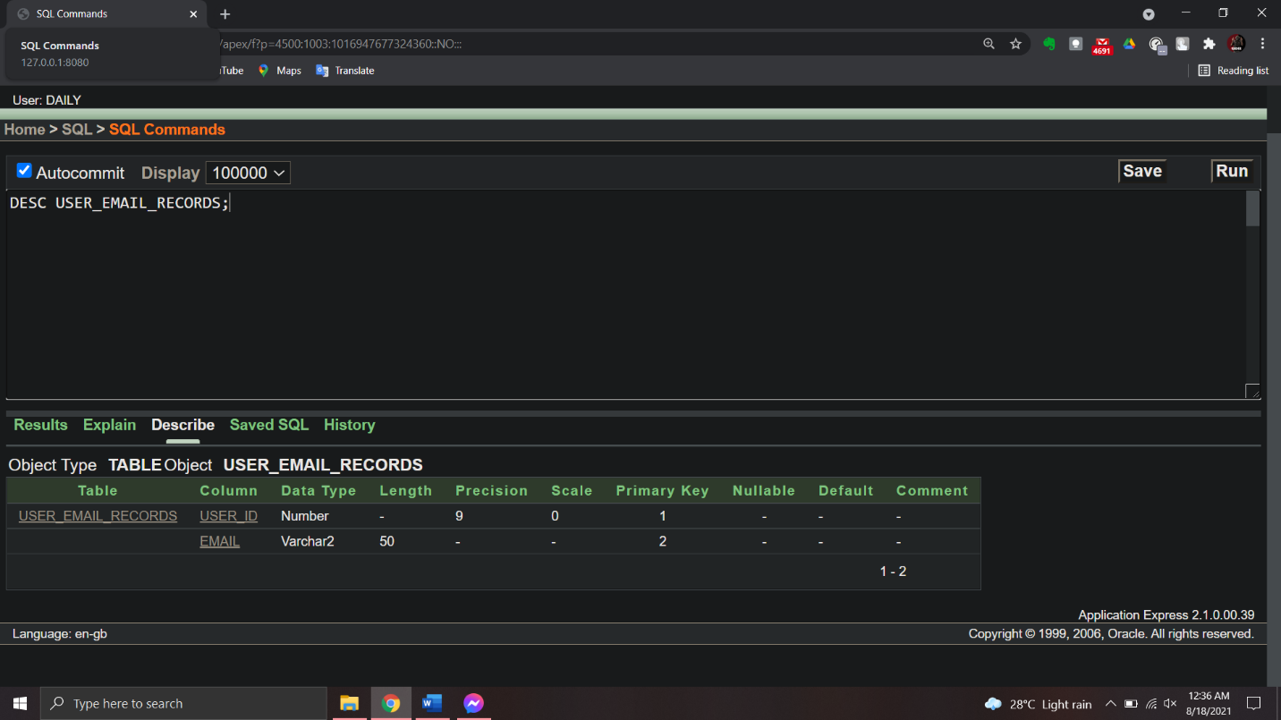

1. **USER_CONTACT_NO_RECORDS:**

1. **USER_ADDRESS_RECORDS:**

1. **USER_DAILY_ACTIVITY_RECORDS:**

1. **DAILY_ACTIVITY_RECORDS:**

1. **USER_CALORIE_BURNING_RECORDS:**

1. **CAL_BURNT_BY_ACT_RECORDS:**

1. **USER_CALORIE_GAINING_RECORDS:**

1. **FOOD_RECORDS:**

1. **USER_TRANSACTION_RECORDS:**

1. **TRANSACTION_RECORDS:**

1. **CLASS_RECORDS:**

1. **USER_CLASS_RECORDS:**

**TABLE DATA**

1. **USER_RECORDS:**

1. **WEIGHT_STATUS:**

1. **USER_EMAIL_RECORDS:**

1. **USER_CONTACT_NO_RECORDS:**

1. **USER_ADDRESS_RECORDS:**

1. **USER_DAILY_ACTIVITY_RECORDS:**

1. **DAILY_ACTIVITY_RECORDS:**

1. **USER_CALORIE_BURNING_RECORDS:**

1. **CAL_BURNT_BY_ACT_RECORDS:**

1. **USER_CALORIE_GAINING_RECORDS:**

1. **FOOD_RECORDS:**

1. **USER_TRANSACTION_RECORDS:**

1. **TRANSACTION_RECORDS:**

1. **CLASS_RECORDS:**

1. **USER_CLASS_RECORDS:**

**SEQUENCE:**

**ALL CONSTRAINTS**

**SOME QUESTIONS FROM EACH TOPIC:**

1. CREATE A COLUMN BMI WHICH WILL CALCULATE THE BMI OF ALL THE USERS AND SHOW USER ID, NAME, BMI AND THE WEIGHT STATUS FROM THE WEIGHT STATUS TABLE. *(JOIN & ARITHMETIC EXPRESSIONS)*

2. SHOW USER_ID, NAME AND CONTACT NO OF ALL THE USERS WHO HAS MORE THAN ONE CONTACT NUMBER*. (JOIN)*

3. SHOW ALL THE ACTIVITES WHICH HAS BEEN DONE BEFORE 12 PM.

4. SHOW ALL THE FOOD WHICH CALORIE IS GREATER THAN ALL THE FOOD NAME START WITH ‘S’ FROM THE FOOD_RECORDS. *(SUB-QUERY)*

5. SHOW ALL THE ACTIVITY WHICH CALORIE IS LESS THAN THE AVERAGE CALORIE FORM CAL_BURNT_BY_ACT_RECORDS. *(SUB-QUERY)*

6. CREATE A COLUMN CALORIE_BURNT AND SHOW THE CALORIE BURNT BY EACH ACTIVITY. *(JOIN)*

7. CREATE A COLUMN TOTAL_MONEY_SPENT AND CALCULATE THE TOTAL MONEY SPENT OF EACH ACTIVITY. *(JOIN)*

8. SHOW THE HIGHEST TOTAL MONEY_SPENT OF THOSE ACTIVITIES WHICH PAYMENT METHOD IS CREDIT CARD. *(SUB-QUERY)*

9. SHOW ALL THE CLASSES OF CREDIT = 3 AND FACULTY NAME STARTS WITH ‘R’. *(SUB-QUERY)*

10. SHOW TOTAL CREDITS TAKEN BY EACH USER. *(JOIN AND FUNCTIONS)*